Below is the information pertaining to the contributions made by each team member and the test cases ran on the client and server.

**Contributions:**

**James Conway:** *server.c* file and ChatGPT associated files, *Makefile*, and portions of the README.

**Neha Joshi:** *client.c* file and ChatGPT associated files, and portions of the README.

Precursor:

Prior to running any test cases, the team needed to verify that all code was working correctly and would compile. Though the *Makefile* continuously provided errors due to the spacing within the file, it eventually worked and compiled all necessary sources files quickly. Below is an image from that execution:

As you see above, but the *server.c* and *client.c* files compiled into executables (*runServer* and *runClient* respectively). However, at the time of running the *make* command, the *Makefile* has a commented out portion of the removal of the source files. This comment will be removed prior to turn in and when ran, will remove the source files.

Additionally, the team needed to verify appropriate error handling and thus conducted faulty commands with the executable files.

This error shows that by not providing the port number, the server will provide an error message and segmentation fault; however, when the appropriate syntax is used, the server executes as intended.

Other administrative notes:

The IP address *127.0.0.1* otherwise known as the loopback address is hardcoded into the server and will connect via that IP address. Anytime the client program is ran, the appropriate syntax is *./runClient <IP address> <port>*

**Test Cases:**

1) The first test case that was run was to ensure that more than one connection could be made to the server simultaneously. Our team went through five simultaneous connections with success:

2) Line of text with a *\n* character:

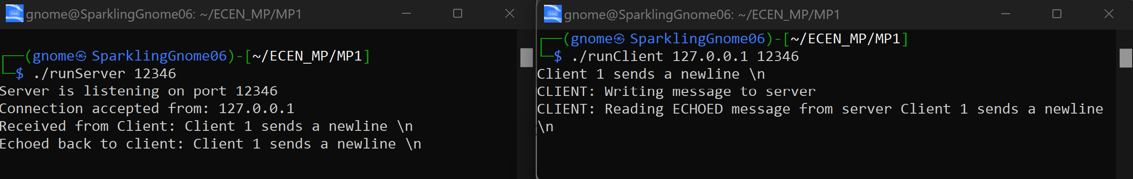

3) Line of text to the maximum length of characters (4095 characters):

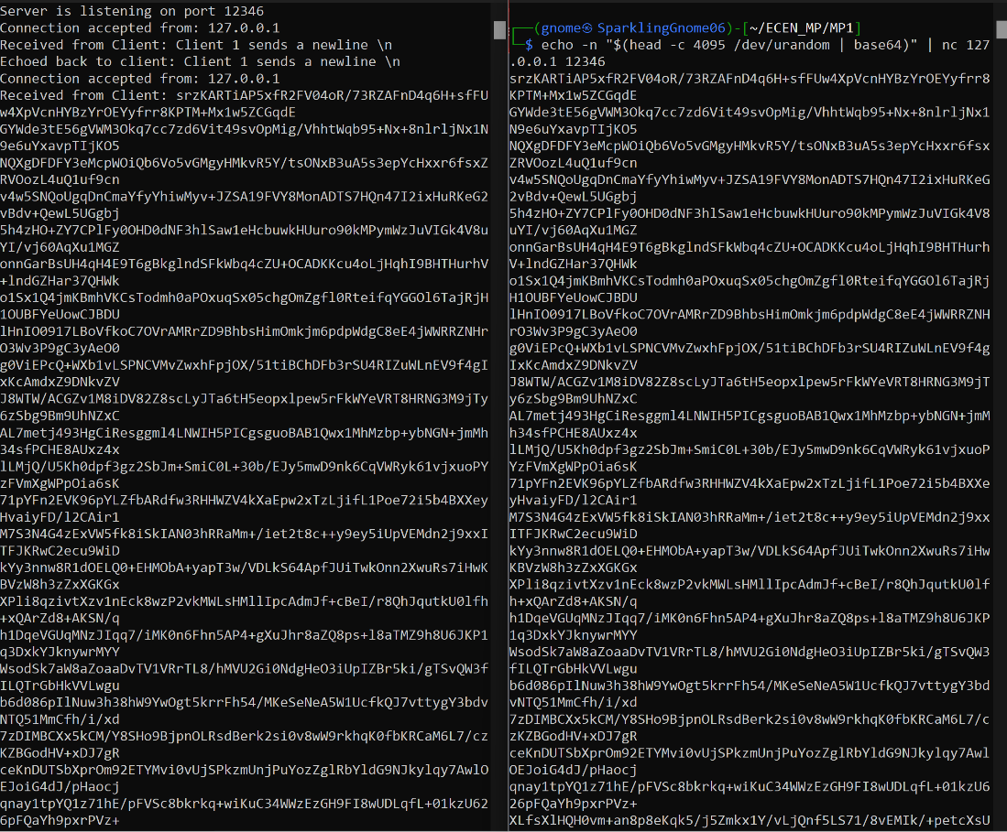

4) Line with no characters and EOF:



Line of no characters was terminated using CTRL+D command

5) Client terminated (using CTRL+C) after entering some text:

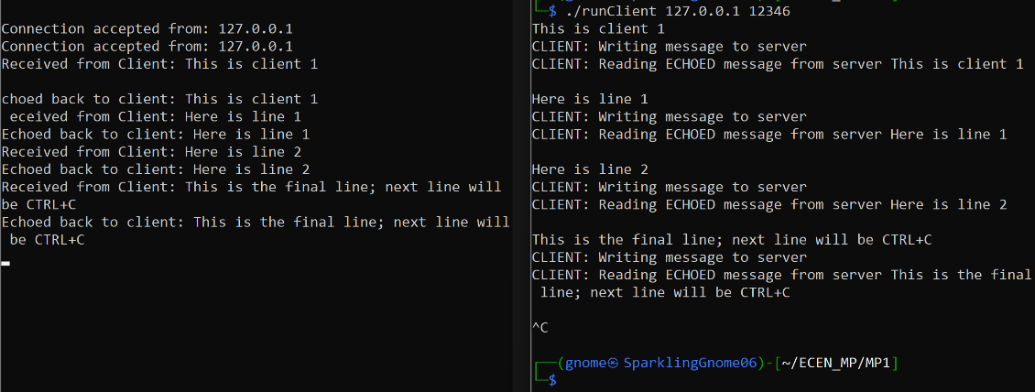

Due to the server being set up to receive multiple clients, there was no message to be output for a loss in connection from the client when terminating using CTRL+C or CTRL+D.